**Successful Encryption**

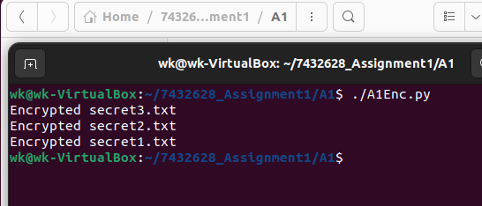

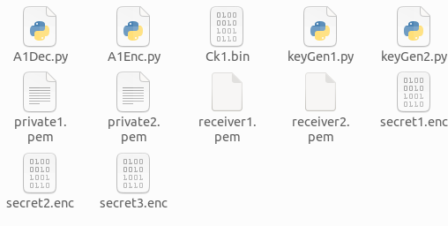

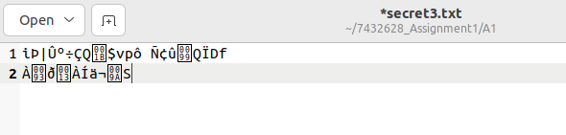

Filename extension changed from .txt to .enc so users are unable to open the file. Even if users are able to open the file, the contents of the file is encrypted and cannot be decrypted without the symmetric and private keys

**Successful decryption**

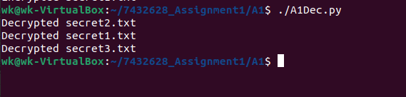

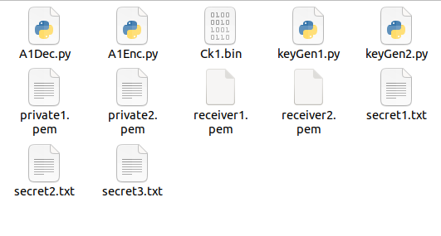

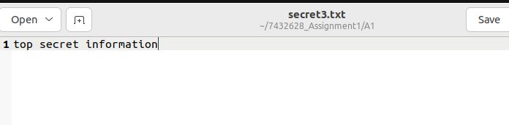

The .enc files are converted back to .txt files. The content inside is decrypted and replaced into the folders as plain text to be read.

**Incorrect ck.bin or private.pem file name**

Enc

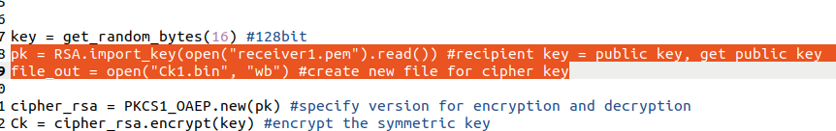

Dec

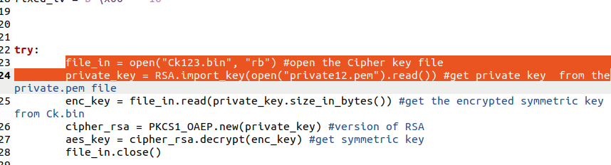

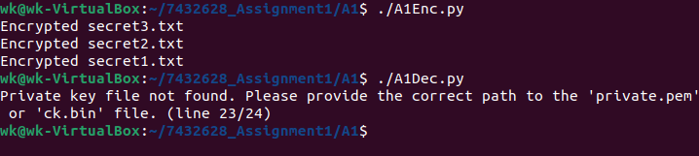

If ck.bin file or the private.pem file does not exist we get an error message asking us to edit the appropriate lines. Once the lines are updated to the correct files, the decryption will work

**Mismatched recipient secret key pair**

Enc with receiver1.pem and ck1.bin

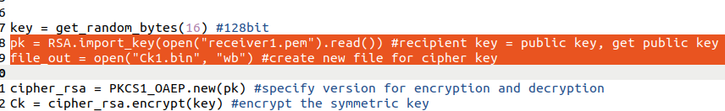

Dec with ck2.bin and private2.pem

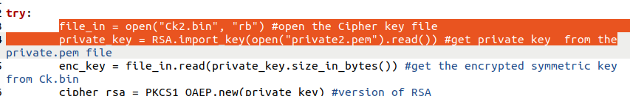

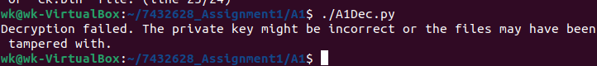

We get an error if there is a mismatch in the key pair. A quick edit of the appropriate lines will allow us to decrypt the encrypted files.